

ICIS-NPDES Unpermitted Facility Plug-In Starter Kit

Installation and Administration Guide

EN-Node

Version: 1.0

January 12, 2012

Logo

1368 How Lane

North Brunswick, New Jersey 08902

[www.enfotech.com](http://www.enfotech.com)

Restriction on Use and Disclosure of Document Information

This document includes data that should not be disclosed outside the business entity for which it was intended, indicated as the recipient on this title page. The entire document is copyrighted by enfoTech and is protected under the US copyright law and international treaties. No part of this document may be reproduced or transmitted in any form or by any means, electronic or mechanical, for any purpose, without express written permission from enfoTech & Consulting Inc.

Copyright © 2001 – 2010 by enfoTech & Consulting Inc. All Rights Reserved.

Revision History

|  |  |  |  |  |
| --- | --- | --- | --- | --- |
| Version | Date | Created By | Reviewed By | Description |
| 1.0 | 01/12/2012 | Peter Huang | Charlie Tsai |  |
|  |  |  |  |  |
|  |  |  |  |  |
|  |  |  |  |  |

Tables of Contents

1. Document Purpose 4

2. Plug-In Overview 4

3. Prerequisites 5

4. Installation Package 5

5. Installation Instruction 5

5.1 Create a ICIS-NPDES Unpermitted Facility staging database 5

5.2 Create a ICIS Domain in the Node Administration Console 6

5.3 Modify DataWizardConfig_UnpermitedFacility.xml 6

5.4 Create a submit web service with the SubmitICISUnpermittedFacility plug-in 7

5.5 Configure SubmitICISUnpermittedFacility plug-in for Operation Manager 8

6. Test ICIS-NPDES Unpermitted Facility Plug-In 10

6.1 Obtain Status and Supplied Transaction ID 10

6.2 Retrieving and Downloading file from Node Client 11

# Document Purpose

The purpose of this document is to provide guidance on the setup, use, and maintenance of the EN-Node ICIS-NPDES Plug-In under the operation for Unpermitted Facility. For short, we will refer to this as ICIS-NPDES Unpermitted Facility.

# Plug-In Overview

The following diagram outlines the ICIS-NPDES Unpermitted Facility plug-in and its interaction with an existing NPDES data management system and EPA.

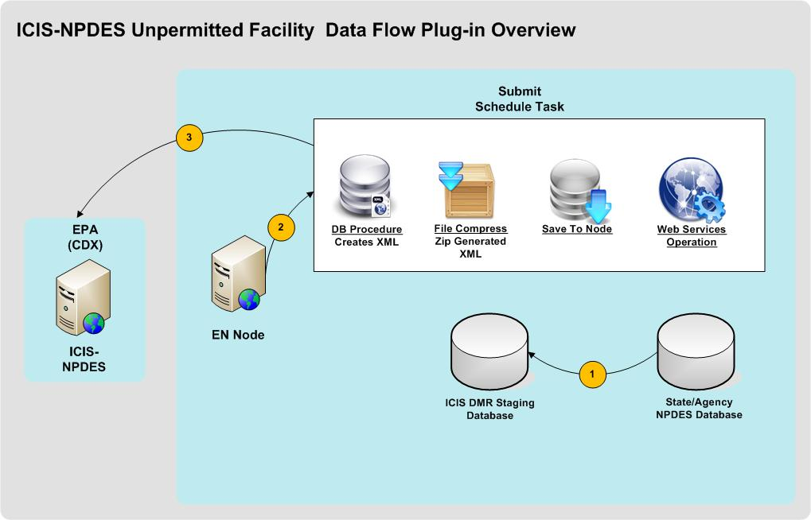

***Figure 1: ICIS-NPDES Unpermitted Facility Data Flow Plug-Ins Overview***

In the following sections and diagram below, the ICIS-NPDES Unpermitted Facility Plug-in is described in detail.



The State or Agency will populate the ICIS Staging Database.

The EN-Node Invokes the SubmitICISUnpermittedFacility plug-in though Node Operation Manager. This process includes the following steps:

1. The plug-in obtains available ICIS-NPDES Unpermitted Facility data from the ICIS staging database.
2. The plug-in executes a Database stored procedure component to generate an ICIS-NPDES Unpermitted Facility XML file.

The plug-in then compresses the XML to a zip file, and submits the result to the EPA. The implementation details are described here:

1. The XML file generated during the previous step will be compressed and saved to the node database
2. An Authenticate web service call will then be invoked using the correct NAAS account information. The NAAS account information is part of the passing parameters to the plug-in.
3. If the Authenticate is successfully executed, a valid security token will be obtained. If the Authenticate fails, the process will end and the incident will be logged with a failed status in the EN-Node
4. The security token and the compressed file are delivered to the CDX via a web service Submit call.
5. The successful result of the submission is determined by obtaining the transaction id.
6. The transaction id will be saved and can be used to retrieve the data.

# Prerequisites

* EN-Node application is installed
* A local ICIS-NPDES data source exists in SQL Server format

# Installation Package

* ICISNPDESStagingDB.zip
* DataWizardConfig_UnpermittedFacility.xml

# Installation Instruction



## Create a ICIS-NPDES Unpermitted Facility staging database

Before any ICIS-NPDES Unpermitted Facility plug-in installation, the user should make sure that the ICIS-NPDES staging database is created and stored in a directory. To do this, execute the following steps:

1. Log in to MS SQL Server as an administrative account.
2. Find the ICISNPDESStagingDB.zip file and unzip it.
3. Open the file into MS SQL Server.
4. Make sure to change the directory within the script to the desired database location before executing ICIS_Stage_DB.sql.
5. Within the store procedure script ICIS_Stage_StoredProcedure.sql, make sure to enter the necessary information for NAAS account. Please see screenshot below:

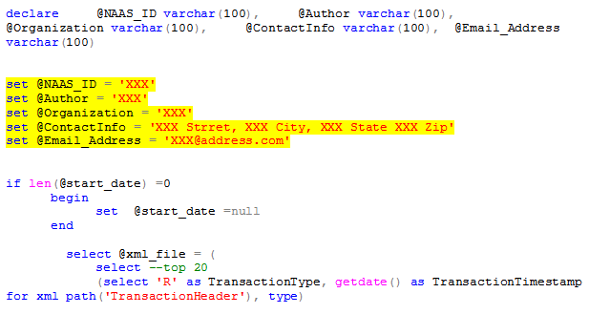

1. Execute the ICIS_Stage_DB.sql before the ICIS_Stage_StoredProcedure.sql. Upon successful execution, the results will be as follows:

* ICIS-NPDES staging table will be created
* ICIS-NPDES stored procedure will be created

## Create a ICIS Domain in the Node Administration Console

In order to create an operation using ICIS-NPDES Unpermitted Facility plug-in under the EN-Node, the user must first create a Domain. The Domain is a logical grouping of operations, as described below:

1. Log into the Node.Administration console with the appropriate username and password.
2. Click the “New Domain” link under the “Node Domain” Module and fill in the following information:
   * **Domain Name:** ICIS
   * **Domain Administrator:** admin (or any other accounts you would like to manage the ICIS file creation process)

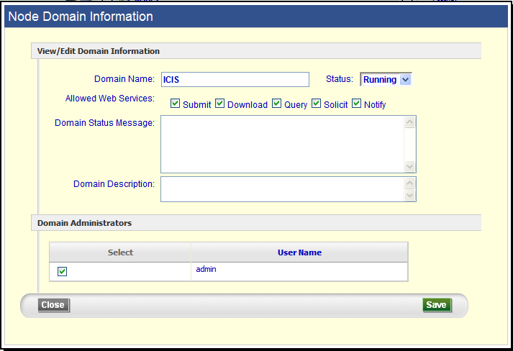

## Modify DataWizardConfig_UnpermitedFacility.xml

1. Before uploading the XML file, the user must make a few modifications within the script. These changes are as follows:

* The server information needs to be changed depending on the user’s specific server and server location in order to connect to ICIS-NPDES staging database.

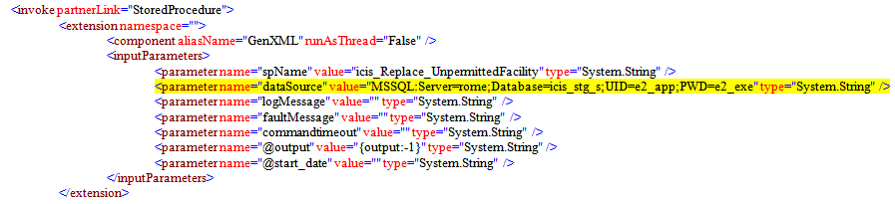

* The endpoint needs to be changed depending on the node version and whether this is in testing or production. The address for different endpoints within ICIS can be found at: <http://www.exchangenetworkwiki.com/wiki/index.php/Node_Endpoints_at_U.S._EPA%27s_Central_Data_Exchange>
* The account information (username and password) also need to be modified to fit the user’s account.

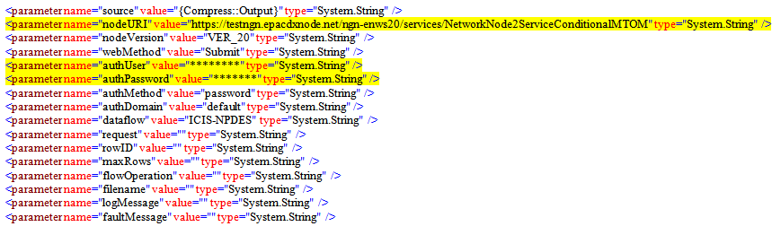

## Create a submit web service with the SubmitICISUnpermittedFacility plug-in

1. Locate the “Node Domains” module from the Node Dashboard.
2. Under the “Node Domains” module, click the “Go to Operations” link for the ICIS Domain
3. Click the “Create Operation by XML” button

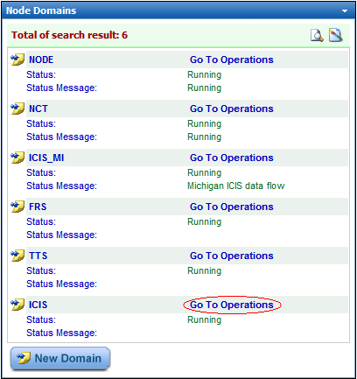

1. In the proceeding page, click “Create Operation by XML”
2. When prompted, locate and upload the DataWizardConfig_UnpermitedFacility.xml file.

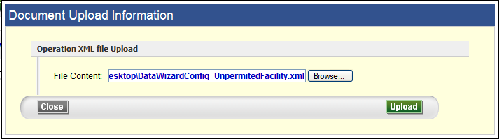

1. After the file is uploaded, the user should be prompted into the task page to modify parameters and run the test. The below screenshot shows the page and an example of filled in parameters:
2. Click Save

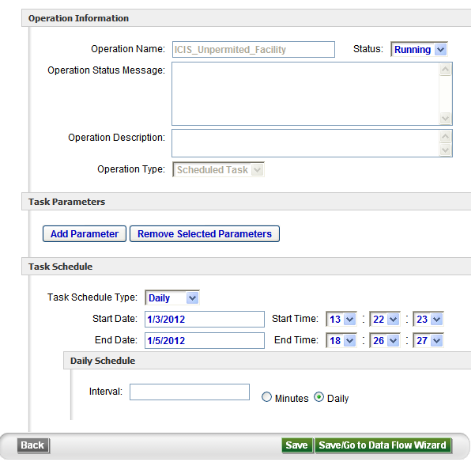

## Configure SubmitICISUnpermittedFacility plug-in for Operation Manager

1. Return to the Node Dashboard screen
2. Under the Node Configuration module, click the icon link for “(7) Operation Manager”

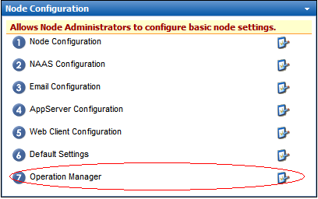

1. Under the Operation Manager screen click the “Add Operation” button
2. Under the Configure Operation section:
   * Select Operation Name = SubmitICISUnpermitedFacility
   * Check Enable Generate, Enable Submit, and Enable GetStatus options
3. Under the Submit section
   * Enter in URL as following:
     + 1. <https://testngn.epacdxnode.net/cdx-enws10/services/NetworkNodePortType_V10> for testing endpoint
       2. <https://cdxnodengn.epa.gov/cdx-enws10/services/NetworkNodePortType_V10> for production endpoint
   * Enter User Name = Enter NAAS assigned User ID
   * Enter Password = Enter NAAS assigned Password
   * Enter Domain Name = default
   * Enter Data Flow Name =ICIS_NPDES
4. Under GetStatus section:
   * Completed Status = Completed
   * Failed Status = Failed
   * Click “Save Operation” button
5. Refer to Screenshot:

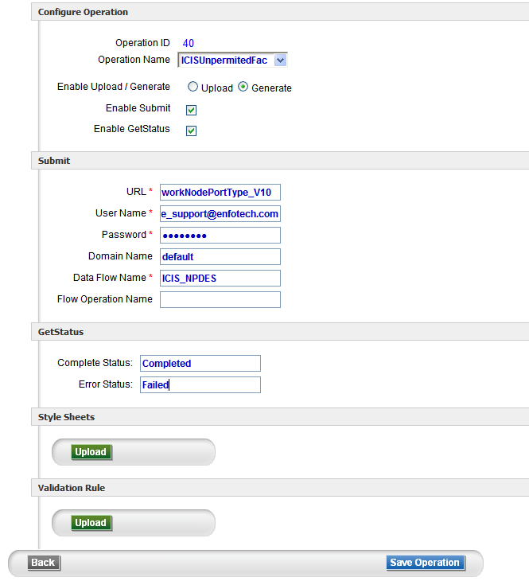

# Test ICIS-NPDES Unpermitted Facility Plug-In

If the ICIS-NPDES staging database has been successfully populated by a local ICIS-NPDES data source from which the user will generate the ICIS-NPDES Unpermitted Facility XML files, the user can then generate the ICIS-NPDES Unpermitted Facility submission file from the ICIS-NPDES staging database and submit to EPA.



## Obtain Status and Supplied Transaction ID

* + - 1. Click on the “Data Viewer” link within the “Favorite Links” module in the dashboard

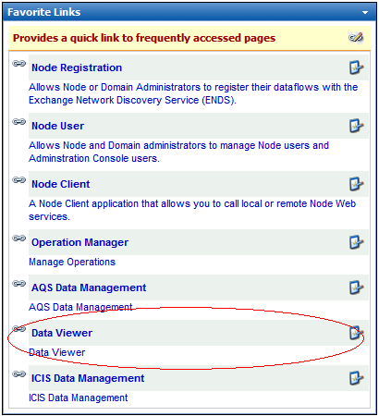

* + - 1. Once in the Data Viewer, input the following information in the fields:
* Select “Demo” under Data Flow
* Select “Operation Manager” under Table
* Click Search
  + - 1. The search should return a list of recent transactions including the status, transaction ID, supplied transaction ID, and submission ID.

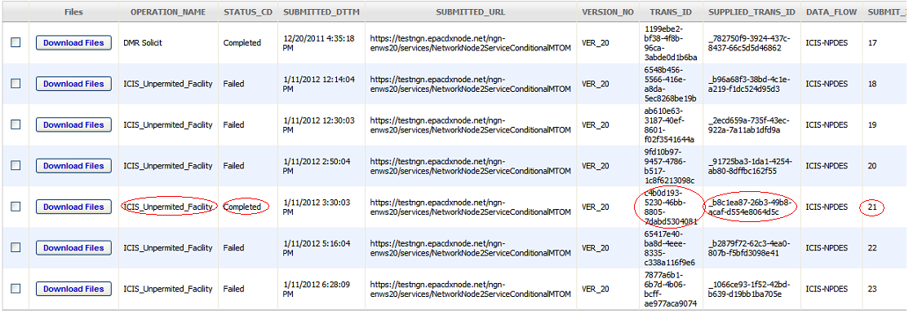

* + - 1. Copy down the supplied ID for future use.

## Retrieving and Downloading file from Node Client

* + - 1. Go to the Node Client website at: <http://192.168.88.203/node.client>
      2. Click “Authenticate” from the menu on the left panel.
* Make sure the node version is node v2.
* Pick the destination Node Address from the dropdown list (in our case, we want to pick testngn).
* Complete the authentication process by entering the NAAS user name and password.
* Click “Authenticate”.
* Once the authentication is complete, the account will be validated and a security token is returned on the bottom of the page.

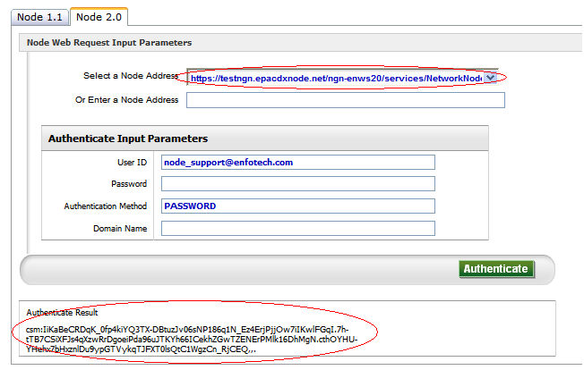

* + - 1. Click “GetStatus” from the menu on the left panel.
* Paste the Transaction ID that was copied in section 6.1.1.
* Click “Get Status”.
* The status should appear on the bottom of the page as either “Completed” or “Failed”. If the status is completed, the file is ready for download.

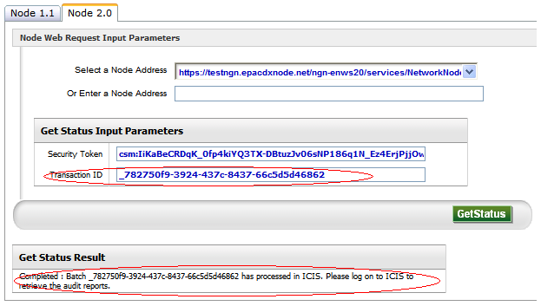

* + - 1. Click “Download” from the menu on the left panel.
* Paste the Transaction ID that was copied in section 6.1.1.
* Enter Data Flow = ICIS-NPDES.
* Click “Download”.
* The files should appear on the bottom of the page, ready to be downloaded.

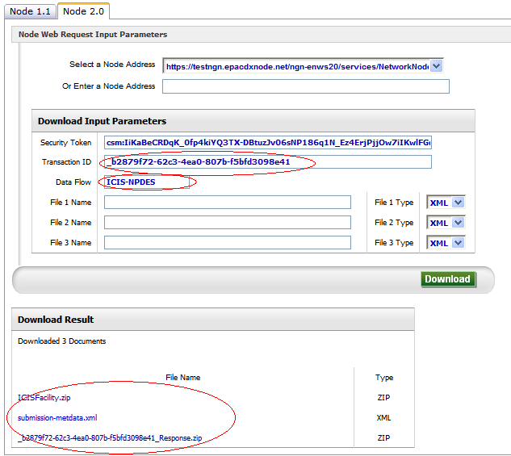

* + - 1. The screenshots below will describe a few cases of the downloaded file. First, check the submission-metdata.xml to check whether or not the file has passed or failed the xml schema validation. If the schema has passed, the user should be able to download the retrieved data. If the schema has failed, the retrieved data will not appear under the download result.
* Passed Schema Validation:

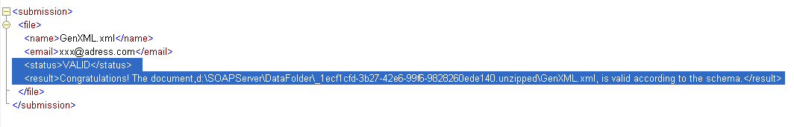

* Failed Schema Validation:

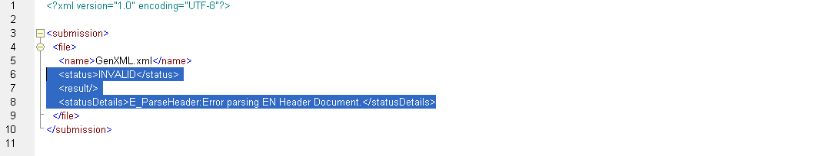

* Passed Schema Validation, Error in Data:

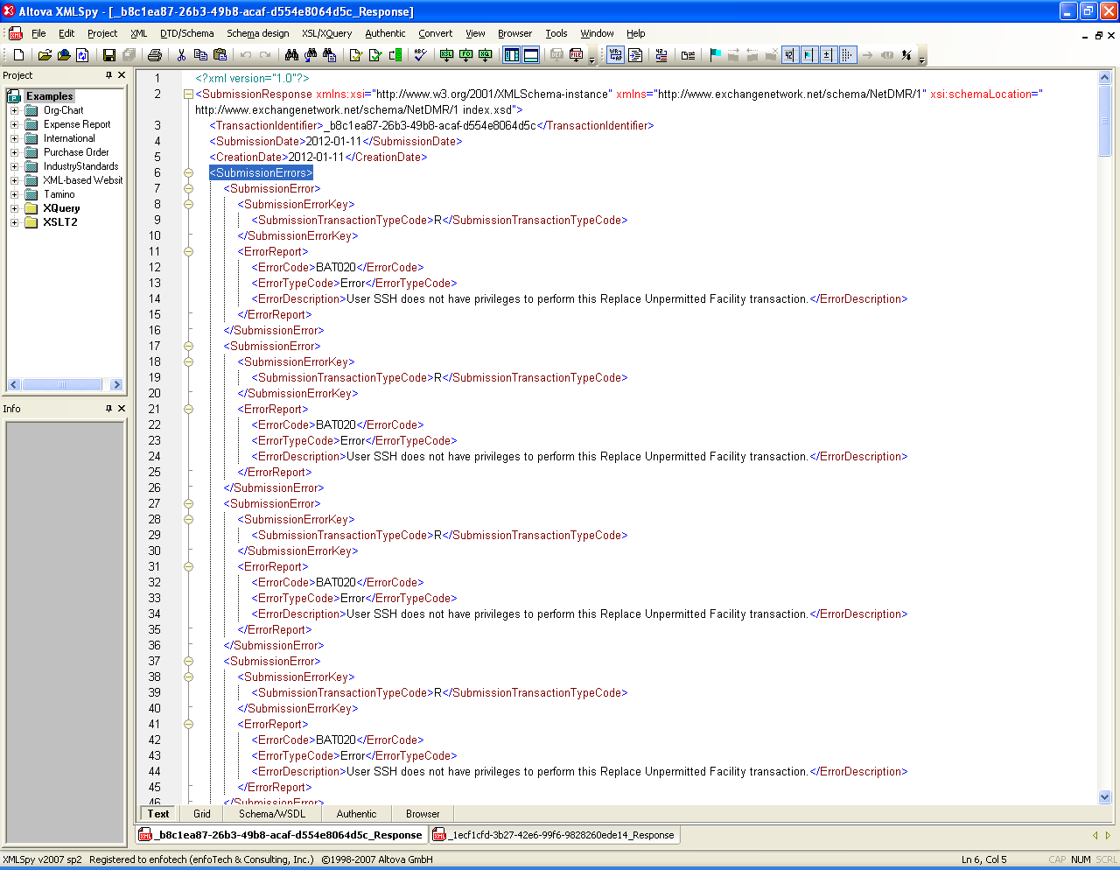

* Passed Schema Validation, No Error in Data:

